AAA COLLEGE OF ENGINEERING AND TECHNOLOGY

Department of Electronics and Communication Engineering

Smart Farmer-IOT Enabled Smart Farming

Application

**IBM NALAIYATHIRAN**

**Web Application Using Node-RED**

|  |  |
| --- | --- |
| **TITLE** | **Smart Farmer-IOT Enabled Smart Farming**  **Application** |
| **DOMAIN NAME** | INTERNET OF THINGS |
| **TEAM ID** | PNT2022TMID51214 |
| **LEADER NAME** | G.KARTHIKA |
| **TEAM MEMBER NAME** | T.ANUSHA  C.ARCHANADEVI  M.KAVIYA |
| **MENTOR NAME** | G.JAYAHARI PRABHU |

Flow 1

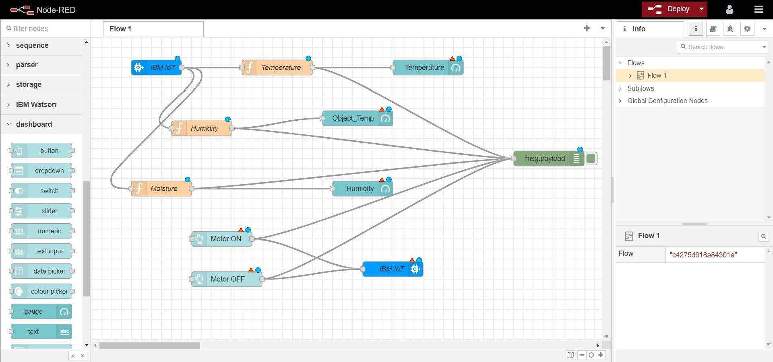

Flow 2:

